**Static Analysis**

1. **System Overview**

**A Stopwatch / Watch application with the ability to be controlled**

**by 2 microcontrollers each Microcontroller has each switches and LCD**

1. **Layered Architecture**

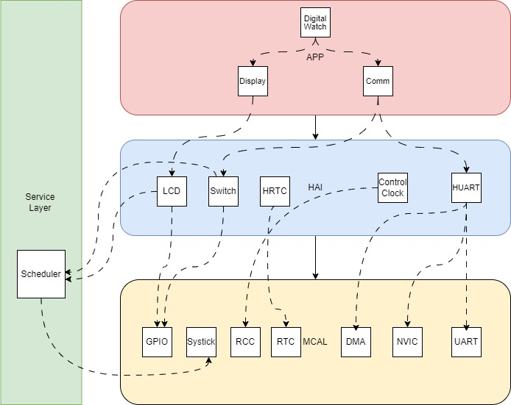

1. **Hardware System Components**
   1. **2 Microcontroller STM32f401CC**
   2. **2 LCD 2x16**
   3. **6 Switches**
2. **API’s For Each Module**

|  |  |
| --- | --- |
| **RCC** | **RCC_Enable_AHB1_Peripheral(uint32_t Copy_AHB2PeripheralName);** |
| **RCC_Enable_AHB2_Peripheral(uint32_t Copy_AHB2PeripheralName)** |
| **RCC_Enable_APB1_Peripheral(uint32_t Copy_AHB2PeripheralName)** |
| **RCC_Enable_APB2_Peripheral(uint32_t Copy_AHB2PeripheralName)** |
| **SYSTICK** | **STK_Start(void);** |
| **STK_SetConfig(uint32_t Copy_Mode);** |
| **STK_SetTimeMs(uint32_t Copy_TimeMs);** |
| **STK_SetCallBack(STK_CBF_t Copy_CallBack);** |
| **GPIO** | **GPIO_InitPin (GPIO_Config_t *Loc_GPIOElement);** |
| **GPIO_Set_PinValue(void *Port , uint32_t Copy_PinNum , uint32_t Copy_PinState );** |
| **GPIO_Get_GetPinValue(void *Port , uint32_t Copy_PinNum, uint8_t * PinStatus) ;** |
| **GPIO_Get_GetPinValue(void *Port , uint32_t Copy_PinNum, uint8_t * PinStatus) ;** |
| **NVIC** | **Enable_NVIC_IRQ(IRQn_t IRQn);** |
| **Set_Interrupt_Priority(IRQn_t IRQn, uint8_t Copy_PreemptGroup ,uint8_t Copy_SubpriorityGroup ,uint32_t GroupPriority );** |
| **USART** | **USART_Init(void);** |
| **USART_Init(void);** |
| **USART_GetByte(USART_UserReq_t* Ptr_UserReq);** |
| **USART_TxBufferAsyncZeroCopy(USART_UserReq_t* Ptr_UserReq );** |
| **USART_RxBufferAsyncZeroCopy(USART_UserReq_t* Ptr_UserReq );** |
| **SWITCH** | **HSwitch_Init (void);** |
| **HSwitch_Get_Status(uint32_t Copy_HSwitchName , uint8_t* Ptr_Status );** |
| **LCD** | **LCD_Set_CursorPosAsync(uint8_t Copy_LCDPosX , uint8_t Copy_LCDPosY );** |
| **LCD_Get_Status(uint8_t* Ptr_LCDStatus);** |
| **LCD_Clear_ScreenAsync(void);** |
| **LCD_Write_StringAsync(const uint8_t* Ptr_string, uint16_t size);** |
| **LCD_Write_NUmberAsync(uint32_t Copy_Number);** |

1. **Messages**

|  |  |  |  |
| --- | --- | --- | --- |
| **MSG_NAME** | **Increment /Reset** | **Mode** | **Edit/Start-Pause** |
| **MSG_Value** | **0x10** | **0x20** | **0x30** |

1. **Switch Table**

|  |  |  |  |
| --- | --- | --- | --- |
| **MSG_NAME** | **Increment /Reset** | **Mode** | **Edit/Start-Pause** |
| **MSG_Value** | **0x10** | **0x20** | **0x30** |
| **Date & Time** | **None** | **Switch to Stopwatch** | **Edit Date and Time** |
| **Edit Date & Time** | **Increment Current Digit** | **Exit Edit and go to Show Date & Time** | **Move to next digit to edit it** |
| **Stopwatch** | **Reset Stopwatch** | **Switch to Date and Time** | **Start and pause Stopwatch** |
| **Pressing Mode with Edit/Start-Pause for 5 Sec will reset the whole system** | | | |